Beyond hype: 70 percent will use data analytics by 2013
By Bill Detwiler
November 29, 2012, 11:34 AM PST
Takeaway: Survey of over 1,300 TechRepublic and ZDNet members shows a growing expectation that data analytics and big data will have a major impact on businesses’ performance in the next two years.
In November 2012, we invited TechRepublic and ZDNet members to take our Analytics/Big Data survey. Worldwide over 1,300 people responded, sharing their company’s current strategy, future plans, and expectations.
The results reveal a widespread use of data analytics, but a limited deployment of big data platforms. This may change, however, given that our analysis also shows a growing expectation that data analytics and big data will have a major impact on businesses’ performance in the next two years.

Majority use data analytics, but extent varies
Globally, just over half (51.7 percent) of respondents said they use data analytics in everyday decision making and processes. And that number is set to rise significantly. If those with plans to use analytics in the next 12 months (18.1 percent) follow through, a wide majority (69.8 percent) of global businesses will be using data analytics by the end of 2013.

Big Data Analytics

Beyond hype: 70 percent will use data analytics by 2013
By Bill Detwiler
Takeaway: Survey of over 1,300 TechRepublic and ZDNet members shows a growing expectation that data analytics and big data will have a major impact on businesses’ performance in the next two years.
In November 2012, we invited TechRepublic and ZDNet members to take our Analytics/Big Data survey. Worldwide over 1,300 people responded, sharing their company’s current strategy, future plans, and expectations.
The results reveal a widespread use of data analytics, but a limited deployment of big data platforms. This may change, however, given that our analysis also shows a growing expectation that data analytics and big data will have a major impact on businesses’ performance in the next two years.

Majority use data analytics, but extent varies
Globally, just over half (51.7 percent) of respondents said they use data analytics in everyday decision making and processes. And that number is set to rise significantly. If those with plans to use analytics in the next 12 months (18.1 percent) follow through, a wide majority (69.8 percent) of global businesses will be using data analytics by the end of 2013.
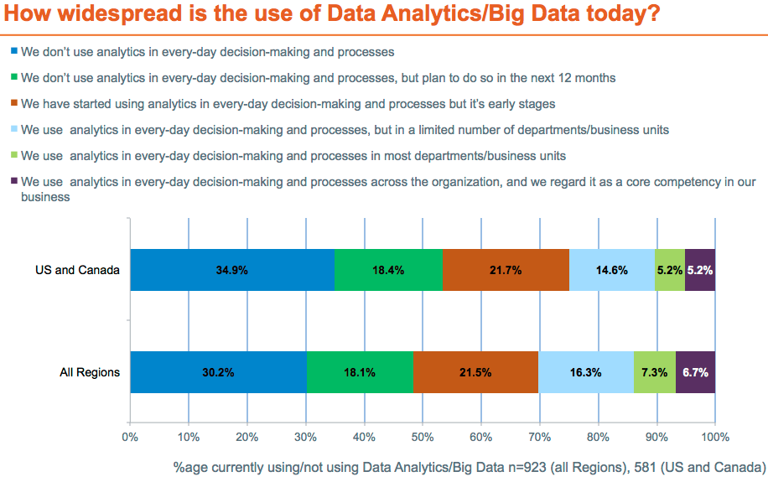
The extent to which companies use data analytics in everyday decision making, however, varies. Globally, 21.5 percent of respondents are in the early stages of use, 16.3 percent use analytics in a limited number of business units, 7.3 percent use it in most business units, and only 6.7 percent use analytics across the organization and regard it as a core competency.

Limited use of big data platforms
Despite over 50 percent of respondents using analytics, just over 10 percent report using big data platforms. 5.5 percent of companies said they source data from a big data platform, such as Hadoop. And only 4.9 percent have an analytics capability that sources data from a data warehouse and a big data platform.
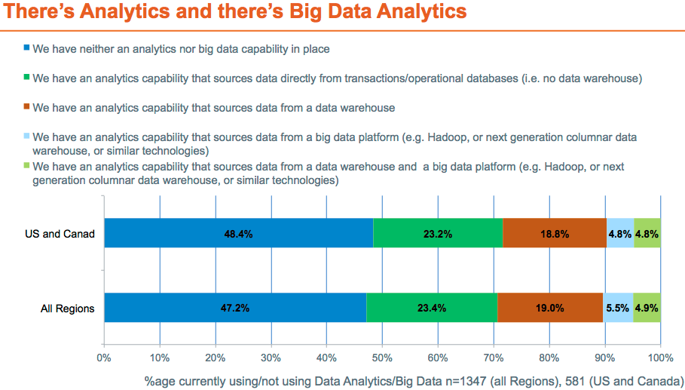

Why businesses aren’t doing analytics yet
Of the companies that aren’t using data analytics, just under half (48.8 percent) either aren’t in an industry with lots of data (35.5 percent) or just don’t see a suitable return (13.5 percent). The other half of respondents do see a potential return, but they’re not using analytics because it’s either not a priority right now (28.1 percent) or they lack the in-house skills to make it work (23.3 percent).
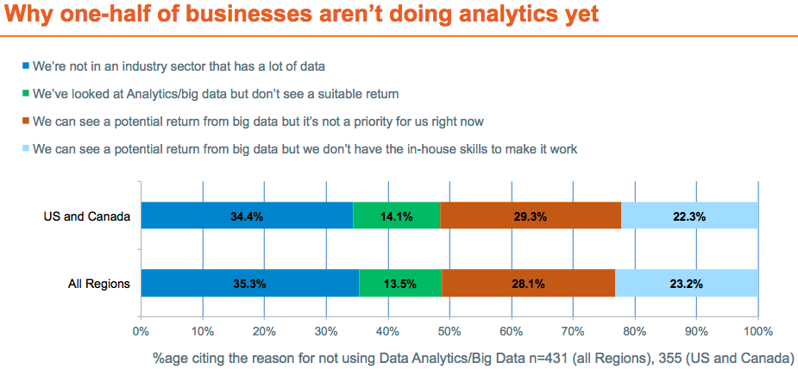

High expectations for analytics and big data
Examining the current state of big data and considering the technology’s future, ZDNet’s Larry Dignan recently wrote:
“If 2012 was the year of big data hype, interest and pilot projects, 2013 will bring production deployments, early returns on investment and a bit of disruption. By 2014, big data projects and systems are likely to be commonplace.”
Our survey results back up Dignan’s roadmap. We asked respondents to rate the potential of data analytics and big data to have a major influence on their organization’s performance and success over the next two years, with a score of 1 being no potential and 10 being great potential. The data shows growing expectations for the technology.
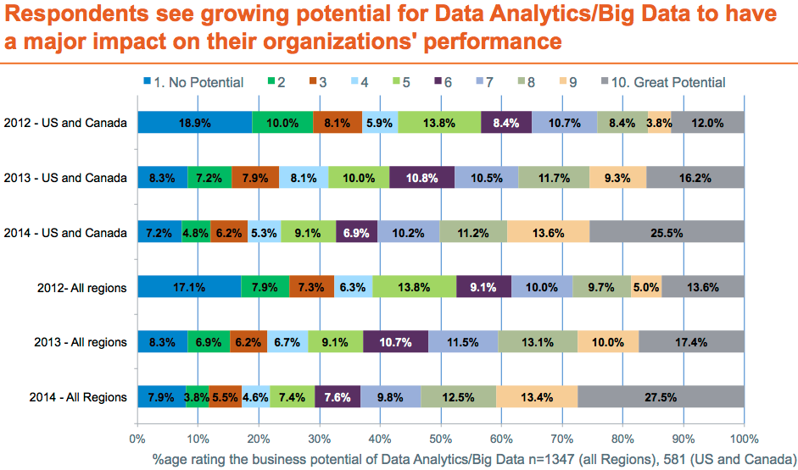
Globally, 28.3 percent rated data analytics and big data a 7 or higher on the scale for 2012. That number jumps to 40.5 percent in 2013 and 53.4 percent in 2014.

Revenue and customers top data analytics/big data priority list
Given these high expectations, what are companies hoping to get from their data analytics/big data investments? In a word, revenue.
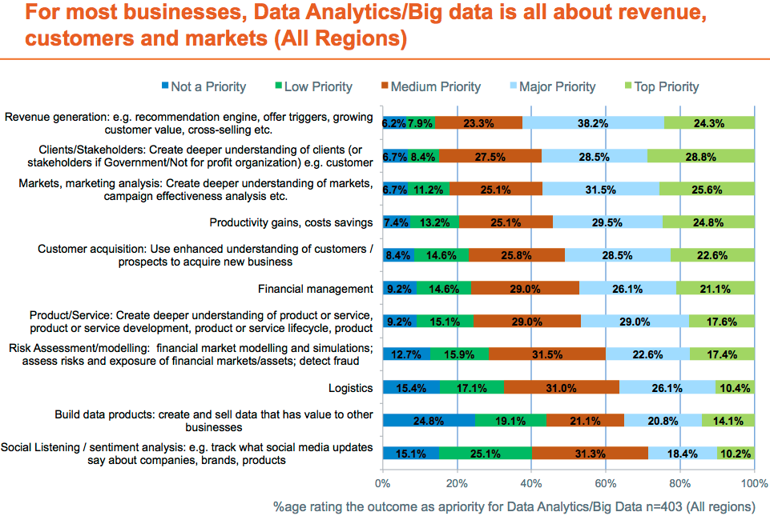
We asked respondents to rate the priority of business outcomes from their data analytics/big data initiatives. Revenue generation topped the list, with 62.5 percent of respondents rating it a major or top priority. 57.3 percent say a better understanding of clients/stakeholders is a major or top priority. Creating a better understanding of markets/marketing analysis (57.1 percent), productivity gains (54.3 percent), and customer acquisition (51.1 percent) round out the top five priorities.
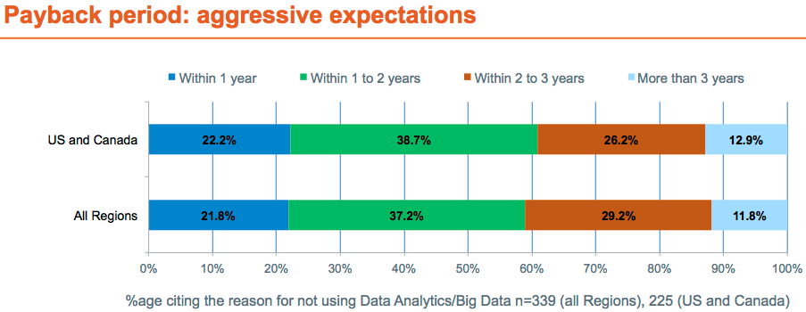
Furthermore, respondents expect to see payback on their investments relatively soon. Around 60 percent of businesses are looking for payback on their investments within two years, with over 20 percent expecting payback within just one year. Only 11.8 percent believe it will take more than three years to achieve payback.

Additional big data resources
- Big Data Primer for IT Pro and Developers (TechRepublic Pro)
- Directory: Big data vendors in the US (TechRepublic)
- TechLines Panel: Big Data Debunked – Finding the Data Signals (ZDNet)

TechRepublic Pro original research
TechRepublic Pro, TechRepublic’s premium service, provides information that IT leaders need to solve today’s toughest IT problems and make informed decisions. This article features preliminary results from the ZDNet Big Data Priorities 2013 report sponsored by D&B. TechRepublic Pro will publish more results from the full report in early 2013. Visit www.techrepublic.com/pro for information on becoming a member.

