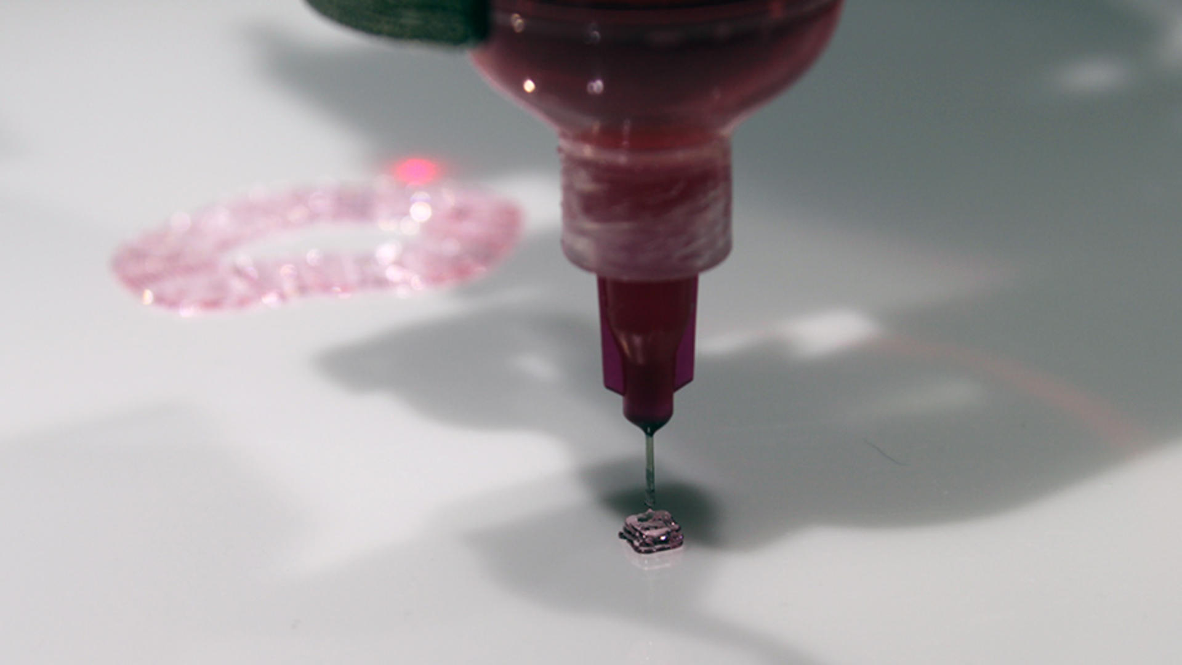

New 3D bioprinter to reproduce human organs, change the face of healthcare: The inside story
By Lyndsey Gilpin
TechRepublic's Jason Hiner also contributed to this article.
Researchers are only steps away from bioprinting tissues and organs to solve a myriad of injuries and illnesses. TechRepublic has the inside story of the new product accelerating the process.
If you want to understand how close the medical community is to a quantum leap forward in 3D bioprinting, then you need to look at the work that one intern is doing this summer at the University of Louisville.
A team of doctors, researchers, technicians, and students at the Cardiovascular Innovation Institute (CII) on Muhammad Ali Boulevard in Louisville, Kentucky swarm around the BioAssembly Tool (BAT), a square black machine that's solid on the bottom and encased in glass on three sides on the top. There's a large stuffed animal bat sitting on the machine and a computer monitor on the side, showing magnified images of the biomaterial that the machine is printing.
This team stands at the forefront of research in 3D bioprinting, as they methodically take steps toward printing a working human heart. As part of this work, the team is also pioneering breakthroughs in printing human stem cells -- a move that could remove the raging ethical dilemmas associated with stem cells and potentially take regenerative medicine to new heights. The combination of these stem cells and 3D bioprinting is going to help repair or replace damaged human organs and tissues, improve surgeries, and ultimately give patients far better outcomes in dealing with a wide range of illnesses and injuries.
But, there are problems with BAT -- as advanced as it is from its surprising background as a military project. It's way too slow and printing anything with it is a tortuously manual process. The printhead runs on a three-axis robot that doesn't handle curves very well.
No one at the lab knows the limitations and challenges of BAT better than a summer intern named Katie, an undergrad from Georgetown University. She's in Louisville as part of a summer program for the Howard Hughes Medical Institute that exposes students to cutting edge research and lets them participate in groundbreaking work. Katie's not sure what she wants to do when she finishes her bachelor's degree in mathematics but she has thrown herself into her work at the CII with full intensity this summer.
A big part of what Katie does is build intricate scripts to tell BAT what to print. It's similar to a computer programmer writing in assembly language to give a computer system an exact set of instructions. It's an incredibly laborious process and it involves Katie going back and forth with Dr. Jay Hoying, the Division Chief of Cardiovascular Therapeutics at CII and one of the leaders of the 3D bioprinting project.
"What's interesting is Katie's background in mathematics," said Hoying, "which is really essential here because it's basically a geometry problem."
But Hoying and his team are about to get a new 3D bioprinting solution that will accelerate their work so significantly that what has taken Katie half the summer will soon take half a day, according to Hoying.
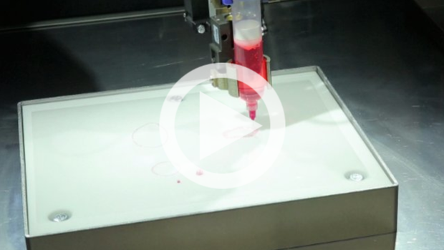
See our companion video: How researchers are using 3D bioprinting to make a human heart
This new solution's hardware, BioAssemblyBot (BAB), runs as a six-axis robot that is far more precise than BAT. The real difference, however, is in the software: Tissue Structure Information Modeling (TSIM), which is basically a CAD program for biology. It takes the manual coding out of the process and replaces it with something that resembles desktop image editing software. It allows the medical researchers to scan and manipulate 3D models of organs and tissues and then use those to make decisions in diagnosing patients. And then, use those same scans to model tissues (and eventually organs) to print using the BAB.
"It's a big step forward in the capability and technology of bioprinting," said Hoying, "but what someone like me is really excited about is now it enables me to do so much more."
Hoying went back to the example of his highly-capable intern, Katie.
"Katie has spent half the summer just understanding and scripting up and doing this," he said. "Now if Katie can do that in half a day, I can do more biology, I can do more experiments. I can explore new cell combinations.... In that same half a summer I could have explored different structures, different cell-[to]-cell combinations, experiment here growing them up, etc. Where she's taking half the summer to understand the geometry, script it out, test it... with the BAB and the TSIM, I would have finished a handful of experiments."
SEE: 3D Printing: Building the Future (a ZDNet/TechRepublic Special Feature)

Bioprinting's new robot
BAB and TSIM are an integrated package built by Advanced Solutions, a private biotech company located in suburban Louisville. The new solution officially launches today -- Friday, August 1, 2014 -- and Hoying's CII is not the only lab ready to jump on it. In fact, Hoying is concerned that demand could be so strong that it could interfere with his facility getting one as soon as he would hope, although that seems unlikely considering Hoying was an important collaborator and consultant for Advanced Solutions in creating the product.
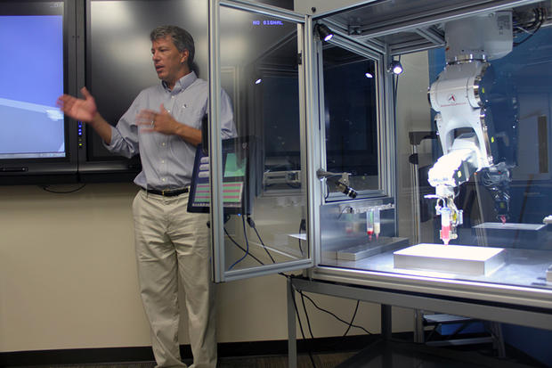
Dr. Jay Hoying explains how BioAssemblyBot (right) will advance the creation of a "Total Bioficial Heart."
Image: Lyndsey Gilpin/TechRepublic
While the lab where Katie and Dr. Hoying run their experiments is downtown next to the hospitals and cutting edge medical facilities, the Advanced Solutions office is about 20 miles east, tucked away in a suburban office park that's also home to a tree care service, a construction company, a dental association, a US Postal Service branch, and a handful of small healthcare companies.
The building that houses Advanced Solutions sits just down a hill off Nelson Miller Parkway, and less than 1000 feet from the I-265 interstate highway. From the outside, there's little indication that the single story brick structure houses a team of 65 people who are working on a hardware and software solution that could revolutionize modern medicine.
Advanced Solutions has been around since 1987. During most of the time since then, it has been a software provider building solutions on top of Autodesk for specific industries. But, in October 2010, Advanced Solutions CEO Michael Golway took an alumni tour of the CII -- since Golway is a University of Louisville alum and the university is a key partner of the facility.
Golway told TechRepublic, "At the end of the presentation, Dr. Stu Williams passionately summarized the CII business model and I was not only impressed by the CII innovation, team of researchers and focus on cardiovascular solutions but intrigued by the possibilities that Advanced Solutions engineering know-how could contribute in a positive and profound way to helping his team. I followed back up with Dr. Williams one-on-one and we became fast friends."
That began the journey that would lead to the integrated solution that Golway and his team devised to meet the needs of Williams, Hoying, and researchers and hospitals throughout the world.
"Over the course of 2.5 years we would periodically meet and I learned about some of the technological workflow challenges that slowed his team from advancing the biology research to achieve the Total Bioficial Heart," Golway said. "Dr. Williams and eventually Dr. Hoying also invested time in learning more about the Advanced Solutions team and our capabilities. After 2.5 years of building a terrific working relationship, listening, learning and collaborating I brought forward an engineering design concept for Dr. Williams and Dr. Hoying to consider that was intended to solve the tissue design technology problem."
Hoying and Williams, who is the division chief of the bioficial heart program at the CII, are both widely respected cell biologists who came to Louisville from Arizona to work together. They were obviously impressed that Golway's solution could get them closer to their goal of creating that "Total Bioficial Heart."
Golway continued, "In March 2013, Advanced Solutions Life Sciences, LLC was formed as a wholly owned subsidiary of Advanced Solutions, Inc. to engineer, fabricate and commercialize the technology in support of that initial concept design. Today the BioAssemblyBot and [the] TSIM software integrated solution are the work product from that endeavor."
Beyond the launch of his company's product, Golway views this work as part of a larger trend of digitizing the medical and biological space, which is destined to unleash other new advances as well.
"It's a big bet for a small company but the great news is we're funding it all ourselves." Michael Golway, Advanced Solutions CEO
"What's been really interesting to me is that we're on a trajectory here where we're really treating biology as more of an information technology," Golway said. "That's incredibly exciting to us because IT grows exponentially -- instead of just the hardcore traditional discovery that biology has been tracking on, if we can translate that into IT we can take that experimentation and rapidly start looking at optimization. How to combine cell types in a way to create cell types and structures. The exponential curve is already there but this technology allows you to take the next step."
The BAB starts at $159,995, which also includes the TSIM software.
"Compared to other products out on the market, it's a very affordable product," Golway said. "Some of the competing products can be 2x, or north of 2x."
He credits getting the price down that low to the convergence of rapidly advancing software and hardware technologies, and a capable, well-rounded team of engineers and designers.
While the Advanced Solutions team was previously focused on being a solutions provider on top of Autodesk, the TSIM software is an independent solution that's not running on top of any other platform. And the BAB is the fruit of hardware expertise that Golway already had on staff or hired to build the integrated hardware/software solution that he believed the bioprinting industry needed to accelerate the work that Williams, Hoying, and others were doing in this exciting new field that holds so much promise for improving the health of humanity.
"It's a big bet for a small company but the great news is we're funding it all ourselves," Golway said. "Failure is not an option."
SEE: Photos: The robot that is going to 3D print a human heart

Beginnings of bioassembly
As technologically advanced and incredible a machine as the BAT is, it resembles something out of the history books when compared to the new BAB prototype running at Advanced Solutions. The BAT is dusty. It whines when it has to work too hard. It's difficult to effectively control.
The BAT, perhaps one of the most cutting-edge bioprinters in existence already, is the third generation of a machine built by Williams -- who started trying to build a 3D bioprinter in 1998 -- along with his team at the University of Arizona and in collaboration with Sciperio.
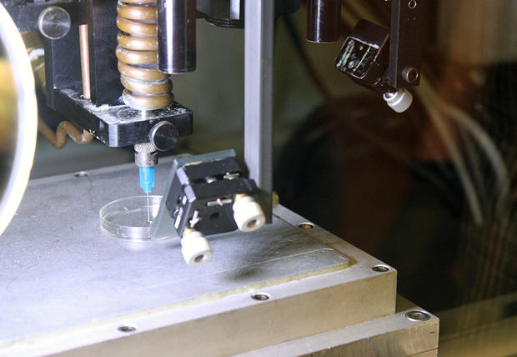
The BioAssembly Tool is a 3D bioprinter built by Dr. Stu Williams and his team at the University of Arizona.
Image: Lyndsey Gilpin/TechRepublic
Fifteen years ago, the Department of Defense approached Williams. They wanted to convert a 3D printer that printed metal into one that could print biological materials. It was an experiment to try to reconstitute a soldier's immune system following a bioterrorism attack, and the first step was to print a lymph node.
The project was funded by the DOD. Williams and his team built the first generation of BAT and eventually printed several lymph nodes successfully.
The BAT came to Louisville in 2007 when Williams and Hoying began working at the CII to advance tissue building and bioprinting. The CII, which is a place for groundbreaking research about cardiovascular disease, stemmed from a partnership between the University of Louisville and Jewish Hospital and St. Mary's Healthcare.
The two men previously worked together at the University of Arizona, where they pioneered research in biomedical engineering. They came to Louisville because of the university's extensive work in cell biology and cardiovascular medicine.
Williams has a rich background in cell biology -- he developed and patented the first methods to use fat-derived stem cells for therapeutic purposes. Hoying has a background in vascular biology. He holds a number of patents himself in growing and manipulating capillaries.
Essentially, the BAT that Williams built functions similarly to the BAB, just at a much slower pace. It builds structures using the traditional 3D printing techniques -- layer by layer, with one main print head.
"We're on a trajectory here where we're really treating biology as more of an information technology." Michael Golway, Advanced Solutions CEO
One of the companies that also uses this original technique is San Diego-based Organovo, which has gotten a lot of attention for its work on 3D bioprinting. But, Organovo is focused on printing cells and tissues, not entire organs.
When TechRepublic visited the CII, four people were crowded around the BAT, trying to figure out where the needle would go next, as it read the script to print a circular shape. Katie and two other lab technicians had to restart the print three times.
An arm that extrudes off the side of the printer holds a giant screen that is filled with numbers -- numbers that were punched in by hand, one by one, through trial and error, to script a mathematical code to build one structure. If one sequence doesn't work, something changes, or a different material is used, the entire script has to be written again.

The complexity of bioprinting
Hoying pulled up a close-up image of skin cells on a desktop computer in an office at the CII. The cells on the screen were tiny, slightly purple, arranged like cobblestones on a road. And they were moving, contracting.
"1...2..." Hoying counted slowly.
The skin cells were beating.
The cells have been reprogrammed to turn into heart cells. They haven't made it all the way there, so they beat much slower than a resting human heart rate of 60 beats per minute.
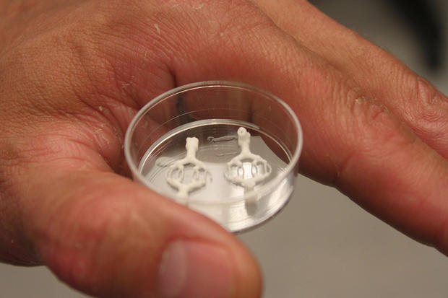
Dr. Jay Hoying holds a capillary bed, printed using hydrogel.
Image: Lyndsey Gilpin/TechRepublic
"Every cell in your body has the same number of genes and the same composition, with a couple of exceptions. So every cell has the potential to be any other cell," Hoying said. "But because of their environment and the instruction they receive in the embryo and then into a fetus and into an adult, certain cells were told to be certain things. So that's part of what we do is figure out how that works."
Turning them back into stem cells is the first step in this process. As complex as it sounds, it is much less so than working with embryonic stem cells, a topic that is the root of many ethical debates.
These reprogrammed cells are adult-derived, called induced pluripotent cells. The ability to transform into another type of cell lies with the genes -- they control what a cell is and does. So, it's possible to turn off one cell behavior (i.e. be an adult tissue cell) and turn on another (i.e. be a stem cell).
Skin cells are just one example. The real experiment has been with fat-derived cells, which are a ready source of cells that are very dynamic and pro-healing. So far, the researchers have combined the fat cells with collagen, which holds them together to form a tissue-like substance, to recreate parts of a heart.
But building a working human heart requires much more than the right kind of muscle cells. Another crucial part of the process involves building the vascular system. One approach the team has explored is sacrificial manufacturing, which is used to build the vascular system. After printing a mold of the capillary bed using hydrogels (the substance inside gel caps), the material is dissolved by being cooled and is then flushed out, creating hollow channels for regenerative fat-derived cells to then be pushed through to form the vascular walls.
"There are some interesting design challenges," Hoying said. "[Like] how do you put cavities in designed structures? It's one thing to create it in 3D space [in the computer], it's another thing to print it and have it sit the way you want it."
Hoying and his team have built a capillary bed from fat-derived cells using this process. Each capillary is less than a quarter the diameter of a human hair, making them difficult to work with, so they rely on the ability of the cells to self-assemble into these small blood vessels.
"We let the biology do the work for us," he said.
This approach is proving successful -- in a trial where the capillary bed was implanted in a mouse, the cells self-assembled into a capillary network, coming together and hooking up to other vessels to allow for blood flow.
"[They] found existing vessels in the animal and tapped into them to start carrying blood. This is a key process to start repairing tissue," Hoying said. "It's one thing to build tissues, but if we don't build a vascular system, they will die."
Down the line, Hoying envisions a relatively simple process during surgery, where the BAB would be present in the operating room. Fat would be removed from the patient through liposuction and then fed into the machine, where the fat cells would be isolated. An hour later, the process of turning the fat cells into the cells the surgeon needs is complete. It would all be automated.
"It's one thing to build tissues, but if we don't build a vascular system, they will die." Jay Hoying, Cardiovascular Innovation Institute
With BAB, all these cells could be fed into the printer, loaded into the cartridges with other biocompatible materials, and -- using a patient-specific MRI or other digital image as a guide -- print them in the shape of the tissue or organ that needs to be replaced, to be handed off to the surgeon.
But this process can't be rushed, and that's why Hoying isn't shy to admit they are only in the research stages. He said that the technology will be ready within three to five years, but there are major hurdles to overcome first. By reconstructing the genes, it's possible to reconstruct them wrong, and if that happens, they could turn into cancer cells.
"If I reprogrammed 80% of them to be heart cells and 20% of them went wonky, I've got a problem. If I even start a wonky cell, it goes wonkier because it likes to continue the path it's on... the biology says that," he said.
If the cells come from the patient's body -- barring any type of cell mutation caused by the researchers -- there is no risk of rejection. It's more complicated scientifically, but it could eventually streamline the process of a patient getting the medical care they need.
"When it gets to regulatory issues, we don't have as many hurdles. It's like helping people sooner," he said.

Hurdles to overcome
FDA regulations will certainly hold up the process, though it's unclear for how long. Once the research phase is complete, the cells will have to be tested on animals, which is why Hoying and Williams are making the prototypes as small as possible. It can take anywhere between two and ten years to get something approved by the FDA.
What may work in favor of Advanced Solutions and the researchers at the University of Louisville, however, is that this is all new territory for the FDA, and the bioprinting landscape is advancing faster than anyone can keep up with.
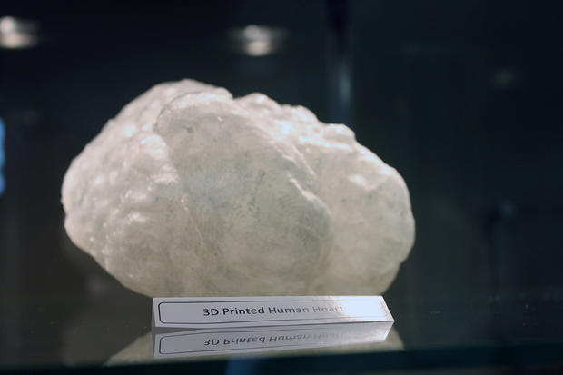
A plastic 3D printed heart in Advanced Solutions office.
Image: Lyndsey Gilpin/TechRepublic
"It's an interesting conversation because the FDA doesn't really know what to do with cells," Hoying said. "They know devices, but they don't know what a cell is because a cell makes multiple drugs, does multiple activities, and if it's from the own patient, that's one thing. But if it's made, harvested and expanded from say, 100 different donors, well now we've got a different ball game."
Currently, there are no distinct regulations for bioprinting, so researchers at academic institutions, research laboratories, and private companies like Advanced Solutions and Organovo -- which is testing pharmaceuticals and tissue assembly -- are experimenting with bioprinting until they are told otherwise.
"It's a little wild west," he said.
"It's a big step forward in the capability and technology of bioprinting." Dr. Jay Hoying, CII
To speed up the process, Williams is working closely with the FDA to define the boundaries of cell therapy and tissue packaging, because there will have to be different rules for different kinds of tissue replacement procedures.
To even reach that point, the researchers still have to overcome the primary obstacles: printing, creating, and testing the cells -- but most importantly, figuring out the basic biology that will allow this to be possible.
Much of the research is stop-and-go. Big breakthroughs come every once in a while, and then the team will work for weeks or months on the same issue. They must make sure the cells are working in concert and the science is advancing efficiently. BAB will give them more freedom to do so, but they will still take it day by day, Hoying said.
Or, perhaps more accurate when referring to 3D printing: layer by layer.

